STRINGS IN JAVA

In java, string is basically an object that represents sequence of char values. Java String provides a lot of concepts that can be performed on a string such as compare, concat, equals, split, length, replace, compareTo, intern, substring etc.

In java, string objects are immutable. Immutable simply means unmodifiable or unchangeable.

String s="CTOOD";

There are two ways to create String object:
1. By string literal
2. By new keyword

1 ) String Literal
Java String literal is created by using double quotes. For
Example:
String s="welcome";

2) By new keyword
String s=new String("Welcome");
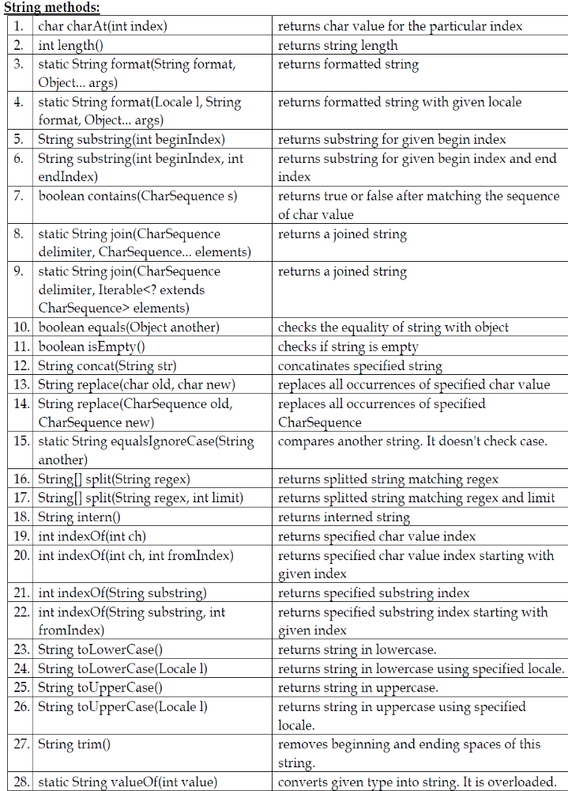
Strings – Printing the odd places in a string

package strings_1;

public class S1Example
{
public static void main(String[] args)
{
String name="LEARN JAVA";
int i;
for(i=0;i<name.length();i++)
{
if(i%2!=0)
{
System.out.println(name.charAt(i));
}
}
System.out.println(name);

}

}
Frequency of the given letter :-
package strings_1;

publicclass S2Example
{

publicstaticvoidmain(String[] args)
{
String name="LEARN JAVA";
inti,c=0;
for(i=0;i<name.length();i++)
{
if(name.charAt(i)=='A')
{
c++;

}
}
System.out.println("The freequency of a is"+c);
System.out.println(name);

}

}

Functions in string to compare with other string

package strings_1;

publicclass S4Example
{

publicstaticvoidmain(String[] args)
{
String s1="Welcome to java";
String s2="Welcome to Java";
System.out.println(s1.equals(s2));
System.out.println(s1.equalsIgnoreCase(s2));
System.out.println(s1.compareTo(s2));
System.out.println(s1.compareToIgnoreCase(s2));
System.out.println(s1.startsWith("Welcome"));
System.out.println(s1.endsWith("Java"));
System.out.println(s1.contains("to"));

}

}

